**Plugin Compile Instructions**

1. Open OSGEO4W shell as administrator as shown in below screenshot.

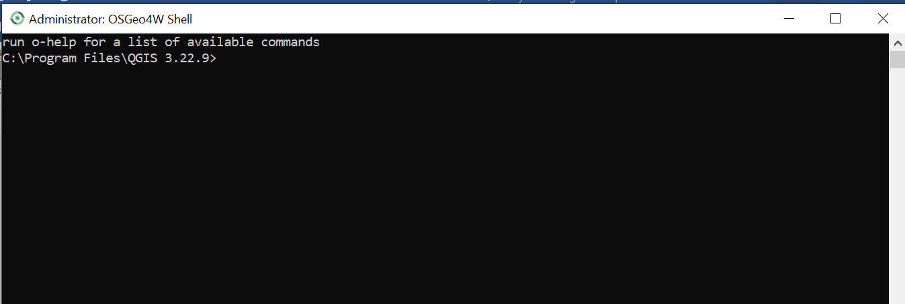

1. Open file location where OSGEO4W is installed as shown in the screenshot below.

* C:\Program Files\QGIS 3.28.0(For Windows)

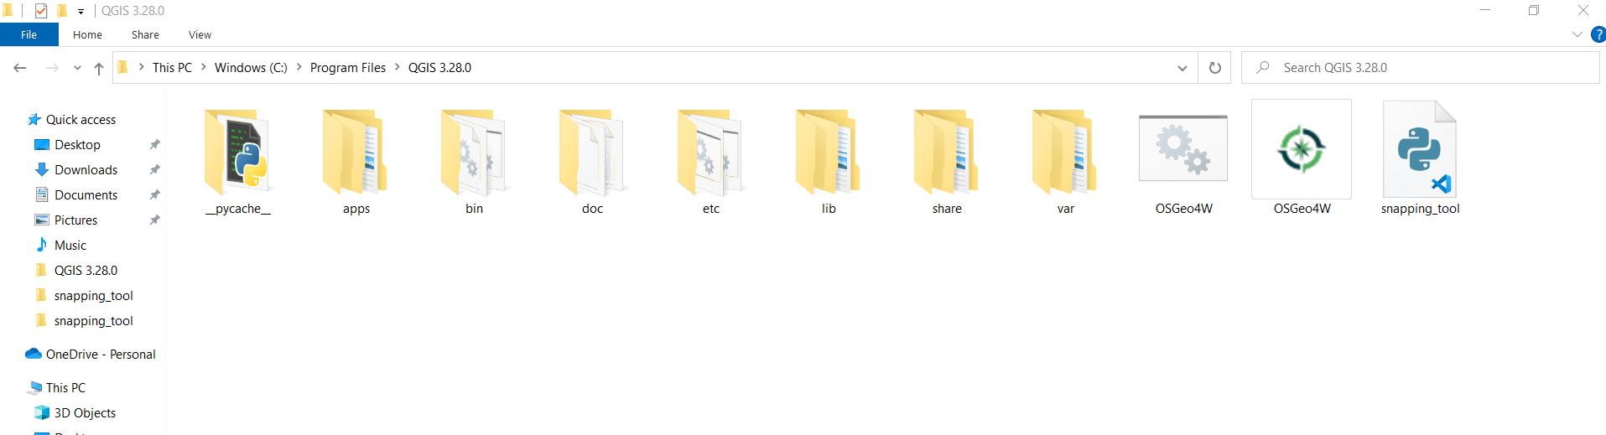

1. Copy the plugin main file (which have all python logic, snapping_tool.py) in the above location which needs to be compiled.

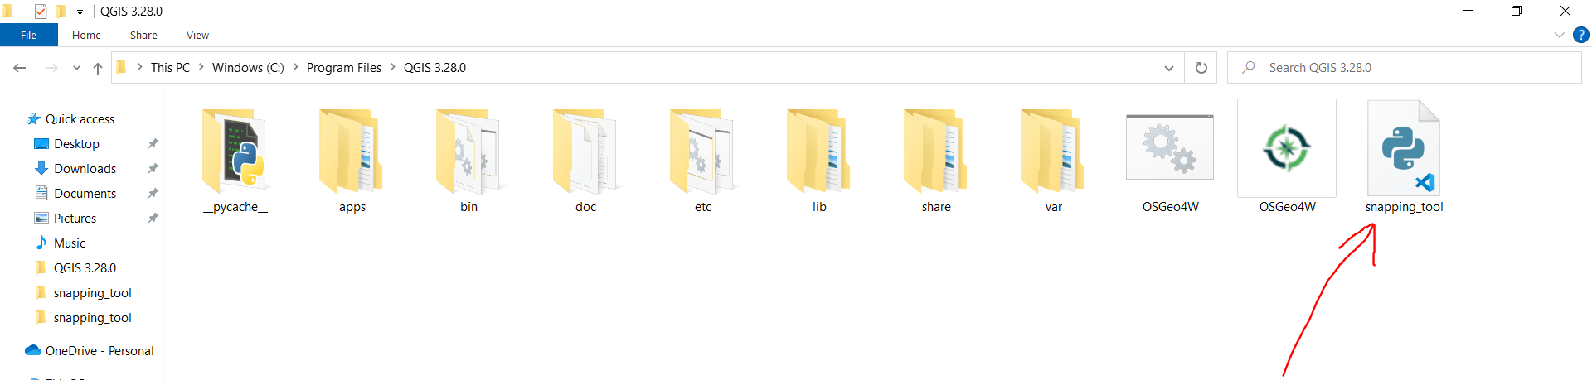

1. In the OSGEO4W shell, now type the below mentioned commands.
2. Type python
3. Import py_compile as pc
4. pc.compile(‘snapping_tool.py’) (In the picture just file name is different.)

On running the above commands, a compiled script is created as shown in the below screenshot.

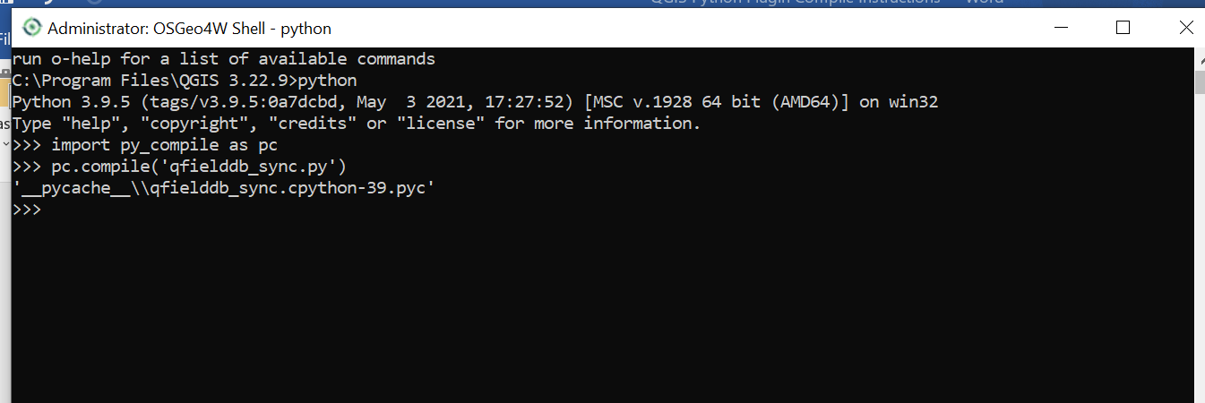

1. Go to the __”pycache__” folder and rename the file as (as origin file name which we just copied here)snapping_tool.pyc.
2. Copy it to the plugin directory and and remove the existing main file(like snnaping_tool.py).
3. Create a zip folder of that directory.
4. Plugin is ready to ship or install in QGIS using Install plugin via zip.

Thanks 😊